영상처리 HW #1

Due date: 30 March

1. Generate a 512x512 raw image, each row of which is a smooth ramp r(n) as shown in the figure below. Display the raw image on a PC monitor using Paint Shop Pro and designate the location of two Mach bands.

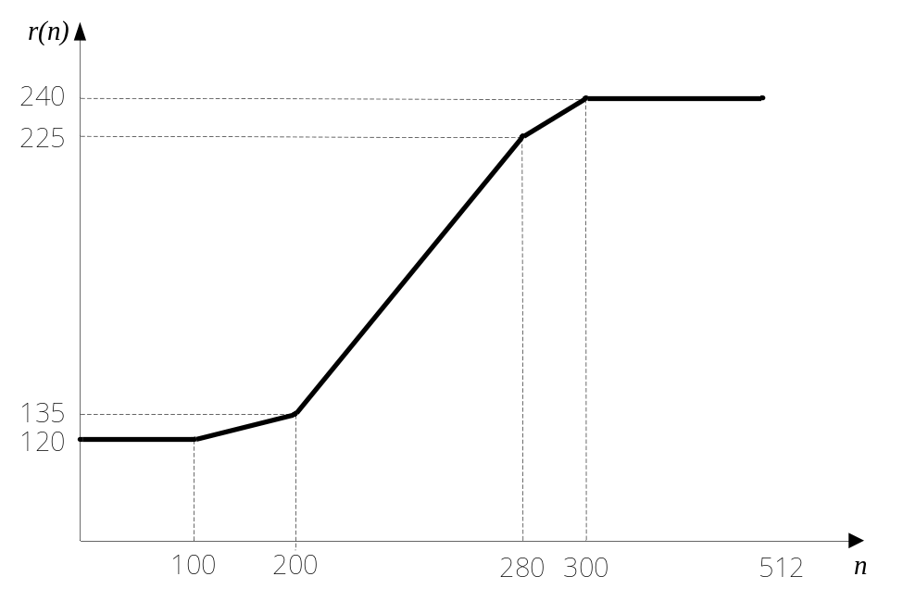

2. Using the raw image generated in the problem 1, generate a BMP (bitmap) image file which can be directly displayed on your PC monitor without executing Paint Shop Pro or Photoshop software.

3. Rotate the image obtained in number 1 90 degrees to the counter-clockwise and store it properly in BMP format as you did in 2. Display the stored BMP image on your PC monitor.

 Please make sure to enclose programming source codes when submitting the report.

